# Cranium Sync-Service - Installation Notes

## Summary

**Cranium Sync-Service installation process – summary:**

1. Install the sync and configuration manager programs.
2. Run the Configuration Manager and add your initial values.
3. Test the Sync by running it manually.
4. Install the Timer Service
5. Open the services dialog, and change the user who the service will run as to *SyncAgent*.
6. Test the system further.

## Install the sync and configuration manager programs

Log on to your server using the windows account which will be used access Microsoft Exchange. This will make sure the files are installed to the correct locations.

As an example we will set up an account called ‘SyncAgent’. The windows username is SyncAgent and the mailbox name is SyncAgent .

Run the file SetupCraniumCafeSync.msi

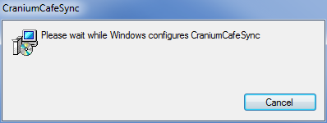

It will install a number of files into the following directory:

**C:\Users\*SyncAgent*\AppData\Roaming\CraniumCafe**

* CraniumCafeConfig.exe
* CraniumSync.exe
* Newtonsoft.Json.dll
* Redemption.dll
* Redemption64.dll

## Run the Configuration Manager and add your initial values.

Run the file: CraniumCafeConfig.exe

In the ‘General’ Tab, enter your API Key and API secret. If you do not have these, you will need to contact Cranium Cafe to get them set up.

Enter the username for the your *SyncAgent* account.

This should also be the windows account you use to test the Sync in the next step. (The system uses Windows authentication, so to log on as that mailbox user to exchange, you must be logged on as that user to Windows.).

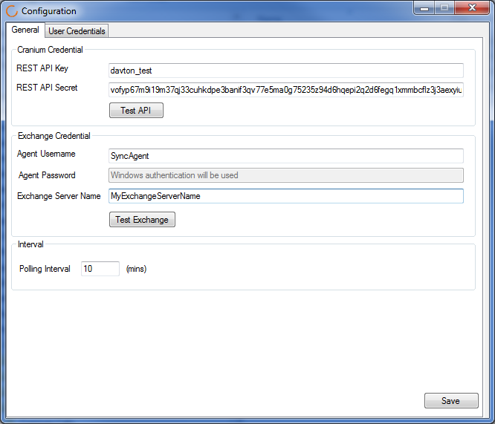

Now select the ‘User Credentials’ tab and add your first Cranium Account. You will need to enter the email address of the user and their Cranium User ID.

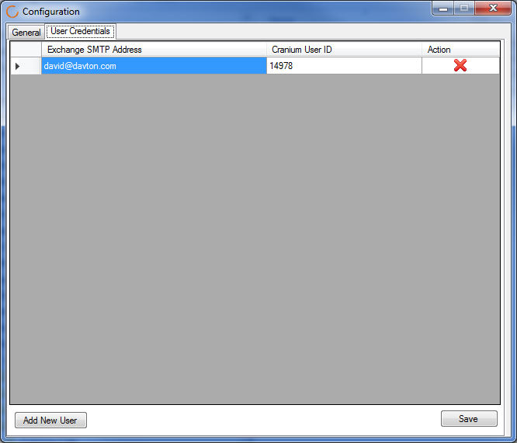

Finally select ‘Save’ to store the data you have added.

## Test the Sync by running it manually

Ensure you are logged in to Windows as ‘SyncAgent’ or whatever your agent account is called (or the sync process won’t be able to log on). Run the file: **CraniumSync.exe**

This file has no user interface, but it will create a log file in the ‘Logs’ folder. (The logs folder is a sub folder of the folder which contains CraniumSync.exe ) The log file will be called ‘CraniumSync-Log (16-04-22).txt’ or similar. (16-04-22 is the date in yy-mm-dd format.)

If the sync shows that it has run in the log file, and if you have successfully entered Appointments in Outlook and can see them in Cranium Cafe, you can move on to the next stage.

## Install the Timer Service

Run the installation file: **SetupTimerServiceII.msi**

This will create a timer service which will run the sync automatically every 10 minutes.

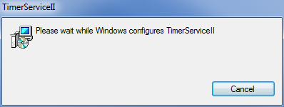

This installs two files to the folder: C:\Program Files (x86)\Davton\TimerServiceII

The files are:

* TimerServiceII.exe
* Settings.xml

The TimeServiceII.exe cannot be run directly. It will have been installed as a service and must be started and stopped from the services dialog.

The settings.xml file contains the location of the sync file which must be run.

<?xml version="1.0" encoding="UTF-8"?>

<Settings>

<DEBUG>True</DEBUG>

<INTERVAL>60</INTERVAL>

<FILEPATH>C:\Users\*SyncAgent*\AppData\Roaming\CraniumCafe\CraniumSync.exe</FILEPATH>  
</Settings>

This needs to be edited so that the <FILEPATH> element points to the correct folder .

E.g. ***Replace *SyncAgent* with whatever is the windows username of the account you will use to run the CraniumSync tool.***

## Open the services dialog, and change the user who the service will run as to ***\*SyncAgent\****.

Search for ‘Services’ and open the Services tool.

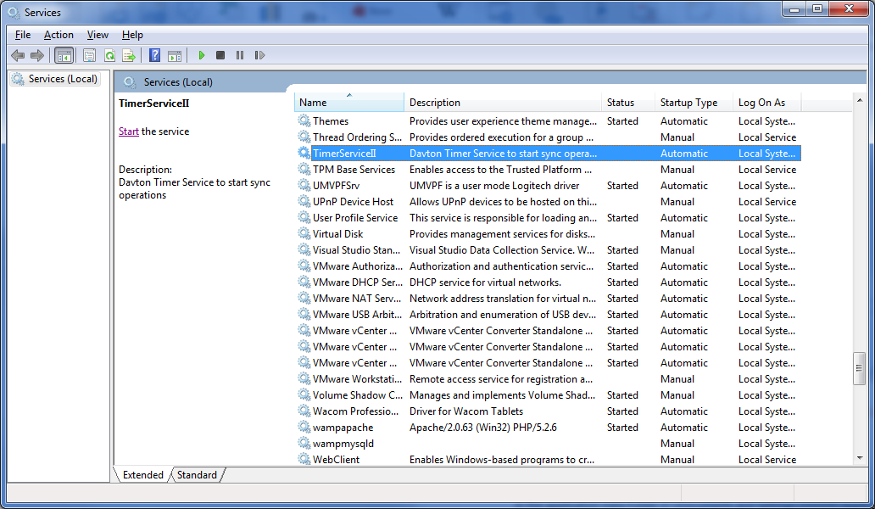

Rightclick TimerServiceII and select Properties

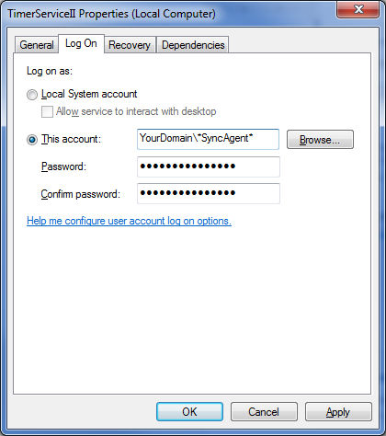

In the log On tab, select ‘This account’ and enter the username and password of your *SyncAgent* account. (Use the format: domain\username ) e.g. Davton2\david

Select Apply. If you get the pasword/username wrong, it will tell you.

Now rightclick the Service and select Start

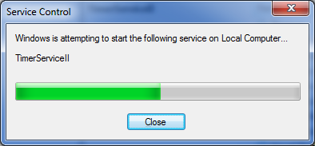

There is no user interface for the Service. You have to review the event logs to find out if it is working. Below you can see the Enet log for Windows Logs / Application showing several entries in the log. If the config file has <DEBUG>True</DEBUG> then it will show more entries than if it has <DEBUG>False</DEBUG . You can manually edit the config file to adjust this.

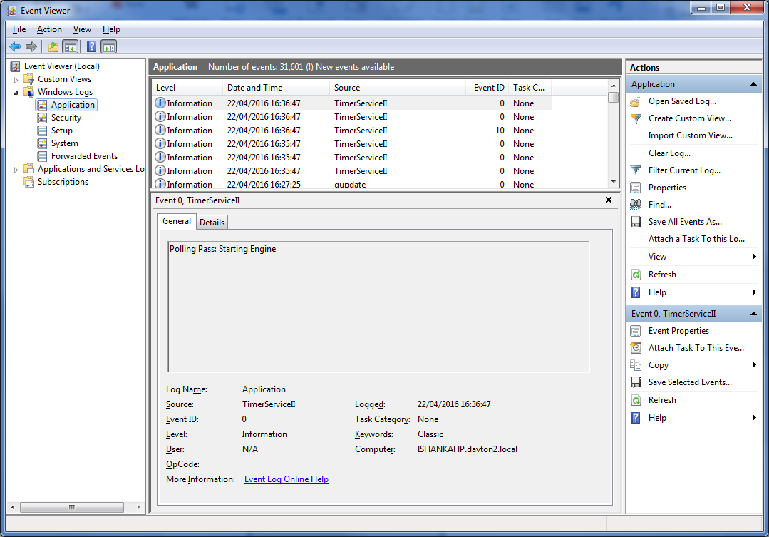

## Test the system further.

With the sync service running, you can add more calendar apointments and make sure they sync to Cranium Café. Once you know the Service is running OK, you can go back to the Configuration tool and add more users.

## Support and Help.

If the installation does not work as expected, please contact cranium Café for support.